14 junio 2021 Aguilar Ortega Uriel

INDEFINITE PRONOUNS / MODAL OF ADVICE

Indefinite pronouns are used to refer to an object or person that is unknown to the speaker.

Some: Somebody- Someone/ Something / Somewhere.

It refers to one person, thing or one part of a group. It’s used in affirmative sentences.

**No: no one-nobody/ nothing /nowhere**

**Remember.**

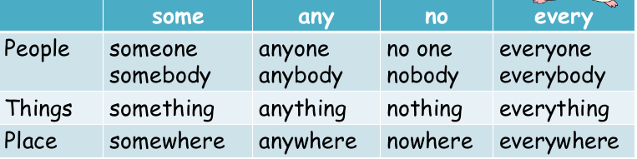

MODALS FOR GIVING ADVICE

* SOULD
* HAD BETTER
* OUGHT TO

YOU SHOULD GO TO THE DOCTOR YOU SHOULDN’T BE LATE FOR CLASS.

YOU OUGHT TO GO TO THE DOCTOR YOU OUGHT NOT TO BE LATE FOR CLASS

YOU HAD BETTER GO TO THE DOCTOR / YOU HAD NOT BETTER BE LATE FOR CLASS

Diagram